OPTIMIZATION OF PROCESS PARAMETERS FOR MILLING OF Ti-6Al-4V ALLOY ADDITIVELY MANUFACTURED

I. Siregar1*, M.S. Adenan2,3 and J.B. Saedon3

¹Department of Industrial Engineering, Faculty of Engineering, Universitas Sumatera Utara, Almamater Rd., 20222, Medan, Indonesia.

²Smart Manufacturing Research Institute,
Universiti Teknologi MARA, 40450, Shah Alam, Selangor, Malaysia.

³School of Mechanical Engineering, College of Engineering,
Universiti Teknologi MARA, 40450, Shah Alam, Selangor, Malaysia.

*Corresponding Author’s Email: ikhsan.siregar@usu.ac.id

Article History: Received 14 September 2025; Revised 12 January 2026; Accepted 5 February 2026

©2026 I. Serigar et al. Published by Penerbit Universiti Teknikal Malaysia Melaka. This is an open article
under the CC-BY-NC-ND license (https://creativecommons.org/licenses/by-nc-nd/4.0/).

ABSTRACT: In this study, Ti6Al4V is employed as the workpiece, which is typically made via metal forming, a widespread process that has always existed. In this study, however, we will use Ti6Al4V generated by Selective Laser Melting and additive manufacturing to create something novel (SLM). The workpiece is milled, and it will later experience the influence of the cutting settings on the workpiece. The purpose of the inquiry is to determine the surface roughness of the workpiece. The parameters used are spindle speed, depth of cut, and feed rate, and three distinct tool models are employed. With this study, we hope to gain a clearer understanding of the effect of cutting settings on Additive manufacturing-formed workpieces. In addition to the workpiece, this study seeks to determine the ideal cutting parameters and their effect on surface roughness. Cutting parameters have an impact, but the differences are rather minor. The experimental results show that surface roughness decreases with increasing spindle speed, with the optimum condition obtained at a spindle speed of 7000 rpm, a depth of cut of 0.1 mm, and a feed rate of 600 mm/min based on the Taguchi method. ANOVA analysis indicates that spindle speed contributes the most to surface roughness (72.14%), followed by feed rate (11.26%), depth of cut (9.82%), and the model (6.78%).
KEYWORDS: Titanium Alloy; Additive Manufacturing; Milling; Surface Roughness

1.0 INTRODUCTION

Additive Manufacturing (AM) has become a transformative innovation in the field of manufacturing, offering alternatives to the limitations of traditional subtractive processes. Unlike conventional machining, which removes material from bulk stock, AM enables the creation of components in a layer-by-layer manner based on 3D numerical models [1-2]. This approach is valued for its material efficiency, design flexibility, and ability to produce complex geometries unattainable by conventional methods. Among additive manufacturing technologies, Selective Laser Melting (SLM) stands out as a key method for fabricating metallic materials.

Titanium and its alloys represent a group of materials that have benefited substantially from AM technologies. Titanium alloys are widely known for their excellent strength-to-weight ratio, high corrosion resistance, and outstanding biocompatibility, making them highly suitable for biomedical, aerospace, and automotive applications [3-4]. One of the most widely used alloys, Ti6Al4V (also referred to as Ti64), has become a focal material for biomedical applications, including orthopedic implants, dental prosthetics, and surgical tools. SLM has been proven to process Ti6Al4V effectively, enabling the production of complex biomedical components with near-net-shape geometries [5-6]. As a result, the fabrication of titanium-based parts through AM, particularly using SLM, continues to be one of the most active and renewable research areas worldwide.

Despite advances in AM, conventional machining remains essential for producing high-quality titanium components. Secondary processes like drilling, turning, and milling are often required to meet strict dimensional and surface requirements, especially in biomedical devices [7–10]. Thus, machining is indispensable and must be continuously optimized to complement AM.

One of the key aspects of machining quality lies in controlling surface roughness. Surface roughness directly influences the mechanical performance, wear resistance, fatigue strength, and biocompatibility of titanium components [4,9]. Moreover, in biomedical applications, surface characteristics can affect osseointegration and cellular adhesion, making surface integrity an even more critical factor. However, controlling surface texture in machining is particularly challenging because it is influenced by multiple interdependent variables, including spindle speed, feed rate, depth of cut, tool geometry, and machine dynamics. Furthermore, surface topography is inherently complex, encompassing multiscale features that require advanced metrological approaches for accurate characterization [11].

Surface roughness is often evaluated using the arithmetic average roughness (Ra), a common industrial practice that overlooks the complex nature of surface textures and their functional effects [12–13].

Systematic methods like the Design of Experiments (DoE) are widely used in manufacturing research. The Taguchi method, in particular, is an efficient tool for optimizing machining parameters with minimal experiments [14]. By using orthogonal arrays, it can evaluate multiple factors at once and identify those most affecting performance. Studies have shown its effectiveness in finding optimal conditions and reducing variability [15–17].

Taguchi-based studies on cutting tools, forces, and power show that machining parameters greatly affect surface roughness and dimensional accuracy [15–17]. Excessive cutting power increases roughness and deviations, while optimized parameters yield smoother, more precise results. However, most research emphasizes machining efficiency or tool performance rather than meeting the strict surface requirements of biomedical components.

This research seeks to fill that gap by focusing specifically on the machining of titanium alloys under varied cutting conditions and analyzing their impact on surface roughness. In particular, spindle speed, depth of cut, and feed rate are chosen as the primary variables because of their significant influence on machining performance and surface integrity. By employing the Taguchi method and analyzing results with ANOVA, this study aims to quantify the contribution of each parameter to surface roughness, identify the optimum machining conditions, and highlight the dominant parameter affecting surface quality.

The novelty of this research lies in its integration of Taguchi optimization with a focus on biomedical manufacturing requirements. While titanium machining has been extensively studied, limited work has been carried out to systematically link machining parameter optimization to the functional requirements of biomedical components, particularly in terms of surface roughness. By emphasizing this connection, the findings of this study not only contribute to the body of knowledge on machining titanium alloys but also provide practical insights for improving the precision and performance of biomedical devices.

In summary, although AM technologies such as SLM have significantly advanced the processing of titanium alloys, machining remains essential for achieving the final surface quality required in biomedical applications. Surface roughness continues to pose a critical challenge, and traditional evaluation methods alone are insufficient to capture its complexity. By applying the Taguchi method to optimize machining parameters, this research addresses both a theoretical gap in understanding the relationship between process parameters and surface quality, as well as a practical need for improved manufacturing strategies in the biomedical sector.

2.0 METHODOLOGY

2.1 Cutting Tool Geometry and Materials

This research uses Titanium Alloy Ti6Al4V because this material is commonly used in the medical world, aerospace and many more [18-19]. However, the reason for using this material is that it has very unique properties in that it is hard [20], so it is interesting if machining is performed on the material. Furthermore, the production of the workpiece is not done in the conventional manner, but through the SLM process, which is one of the AM processes [20-21]. Figure 1 show the sample of the workpiece material. SLM is an AM process that can produce functional prototypes with complex geometries and thin structural walls. In SLM technology, laser energy is used to melt metallic powders in layers to create dense metal parts.
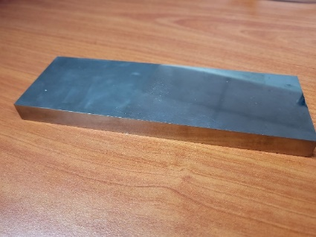

Figure 1: Workpiece Ti6Al4V Material Produced by SLM
Figure 2: Ti6Al4V Powder for SLM

That model is from the powder and process it on SLM in AM. The powder can show on image with Scanning Electron Microscope.

The specification of the powder consists of:

Table 1: Powder Specification
Powder Description | Titanium Alloy powder
Layer Thickness | 30µm and 60 µm
Laser Power | 200 W
Additive Manufacturing System | AM250
This study's employed model There are three types of cutting tools, the first of which is a typical model with four flutes. The second and third models are quite unusual in this study; the second model has variances in pitch, while the third model has differences in the helix angle. Figure 3 illustrates the three models utilized in this research.
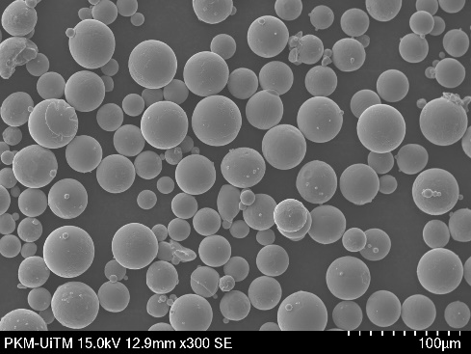
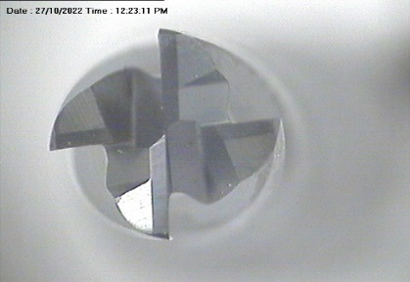
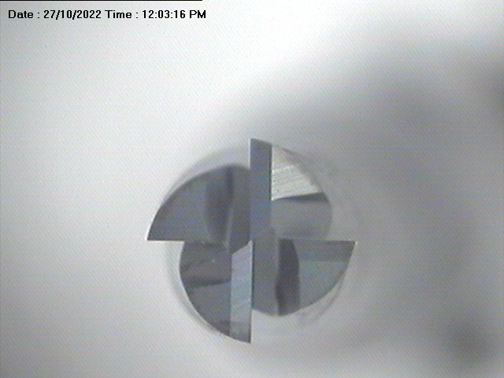
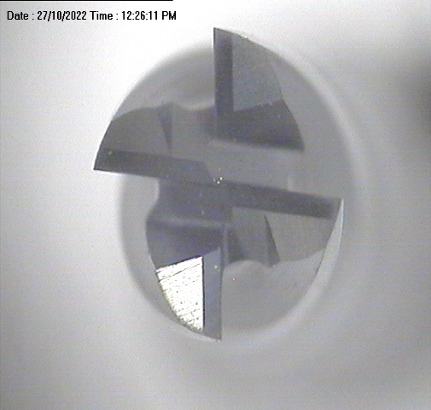
Figure 3: Macrograph of Cutting Tool Models

The CNC Milling Machine model Hass VF 1 was the subject of the research (3axis). High-Speed Machining machine milling is used because of its excellent efficiency, so the researchers chose to use this machine to run the machining process. Within milling operations, the spindle speed represents a pivotal parameter influencing surface roughness. In this particular study, our focus lies on the examination of workpiece surface roughness, emphasizing the significance of the spindle speed variable in the milling process. The parameters with variation of 3 levels used in this study.

Table 2: Cutting Parameter
Symbol | Control Factors | Units | Level
Symbol | Control Factors | Units | 1 | 2 | 3
A | Spindle speed | rpm | 2000 | 5000 | 7000
B | Depth of cut | mm | 0,1 | 0,3 | 0,5
C | Feed rate | mm/min | 600 | 900 | 1200
D | Model |  | 1 | 2 | 3

The cutting parameters and their levels were selected based on machine capability, and commonly applied ranges in high-speed milling operations. Spindle speed, depth of cut, and feed rate were chosen as the primary factors due to their well-established influence on surface roughness, while the model factor was included to account for tool variation. The cutting tests were performed with a spindle speed (n =2000, 5,000 and 7,000 rev/ min) and depth of cut (ap = 0.1, 0.3 and 0.5 mm) under dry cutting conditions. This experiment was carried out with L9 where 9 experiments will be carried out to assess the optimal parameters, details for the distribution of 9 experiments can be seen in the following table 3.

Table 3: Taguchi L9 Experiment
Exp | Spindle Speed | DoC | Feed Rate | Model
1 | 2000 | 0,1 | 600 | 2
2 | 2000 | 0,3 | 900 | 3
3 | 2000 | 0,5 | 1200 | 3
4 | 5000 | 0,5 | 900 | 1
5 | 5000 | 0,5 | 1200 | 2
6 | 5000 | 0,5 | 600 | 2
7 | 7000 | 0,5 | 1200 | 3
8 | 7000 | 0,5 | 600 | 1
9 | 7000 | 0,5 | 900 | 1

2.2 Cutting Tool Geometry and Materials

In this study, will attempt to determine the relationship between the parameters and the observed surface roughness. The total degree of freedom of the selected orthogonal array must be equal to or greater than the sum of the variables, according the Taguchi experimental design method. Consequently, the L9 orthogonal array was chosen for this study.

3.0 RESULTS AND DISCUSSION

In the investigation, the average surface roughness of each cutting parameter was measured. A three-dimensional optical profilometer was utilized for these observations. Using three-dimensional surface studies, the effect of cutting factors on surface quality was clearly revealed from the experimental data. However, this study did not include cutting force measurements, as the primary focus was on evaluating surface roughness.

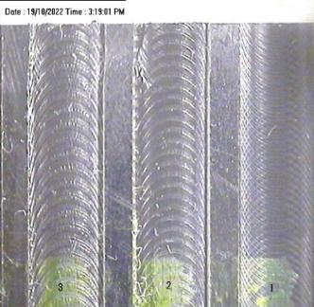
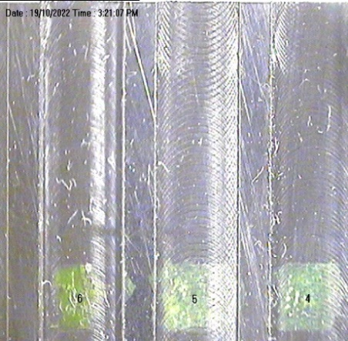
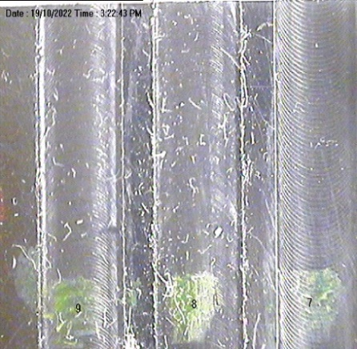

Figure 4: Surface Roughness Illustration

From the experiment, the data shown:

Table 4: Surface Roughness Result
Exp | Spindle Speed (rpm) | DoC (mm) | Feed Rate(mm/min) | Model | Ra
1 | 2000 | 0,1 | 600 | 1 | 0,56
2 | 2000 | 0,3 | 900 | 2 | 1,31
3 | 2000 | 0,5 | 1200 | 3 | 2,06
4 | 5000 | 0,5 | 900 | 3 | 0,46
5 | 5000 | 0,5 | 1200 | 1 | 0,40
6 | 5000 | 0,5 | 600 | 2 | 0,46
7 | 7000 | 0,5 | 1200 | 2 | 0,36
8 | 7000 | 0,5 | 600 | 3 | 0,28
9 | 7000 | 0,5 | 900 | 1 | 0,39

From the table, it is evident that Experiment 3 from Model 3 has a higher surface roughness than other experiments, while Experiment 8 from Model 3 has the lowest surface roughness. Therefore, based on the data, model number 1 is more stable than another model with different parameters.

From the variation tools model, surface roughness in machining varies primarily according on spindle speed, depth of cut, feed rate, and tool shape.

According to the results, the analysis of the orthogonal array was used to evaluate the influence of each process parameter. The table shows that spindle speed has the greatest effect on machining quality, while the tool model has the least effect.
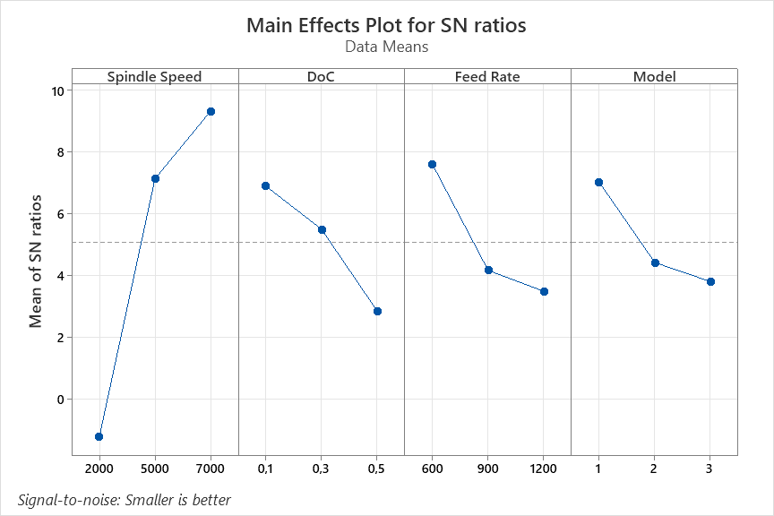

Figure 5: Mean of SN Ratio Taguchi Method
The taguchi table above shows that the perfect or the optimum condition for this experiment are:
- spindle speed 7000 rpm
- depth of cut 0,1 mm
- feed rate 600 mm/min

Table 5: Analysis of Variance for Means
Source | DF | Seq SS | Adj SS | Adj MS | P
Spindle Speed | 2 | 1,70241 | 1,70241 | 0,851205 | 72,14
DoC | 2 | 0,39845 | 0,39845 | 0,199223 | 9,82
Feed Rate | 2 | 0,38905 | 0,38905 | 0,194527 | 11,26
Residual Error | 0 | * | * | *
Total | 8 | 2,84092

Table 5 shows that the most influence on this research respectively are spindle speed, feed rate, depth of cut and model. In this study, the Taguchi L9 orthogonal array was applied without replication. As a result, no degrees of freedom remained for the error term, which prevented the calculation of the mean square error (MSE) and the corresponding p-values. To address this limitation, the analysis focused on the contribution percentage of each factor and the main effect plots, which are standard practices in Taguchi-based experimental designs. Future studies may incorporate replication or pooling of non-significant factors to enable the estimation of error and statistical validation.
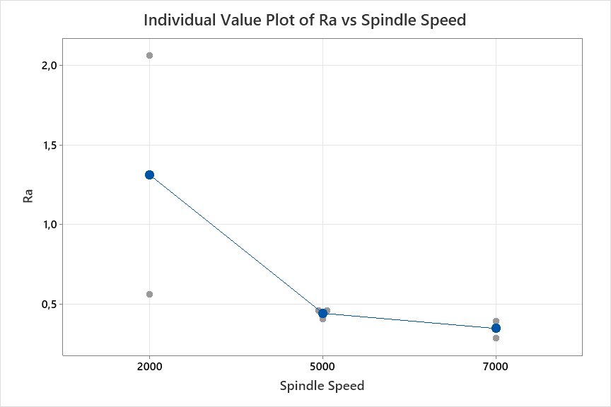
Figure 6: Correlation Ra and Spindle Speed

From the experiment and analysis with Anova, get the result on Figure 6 that Spindle Speed higher the surface roughness more reduces the value. This is related from the research done before [22,25]. The higher spindle speed is the best for surface roughness.
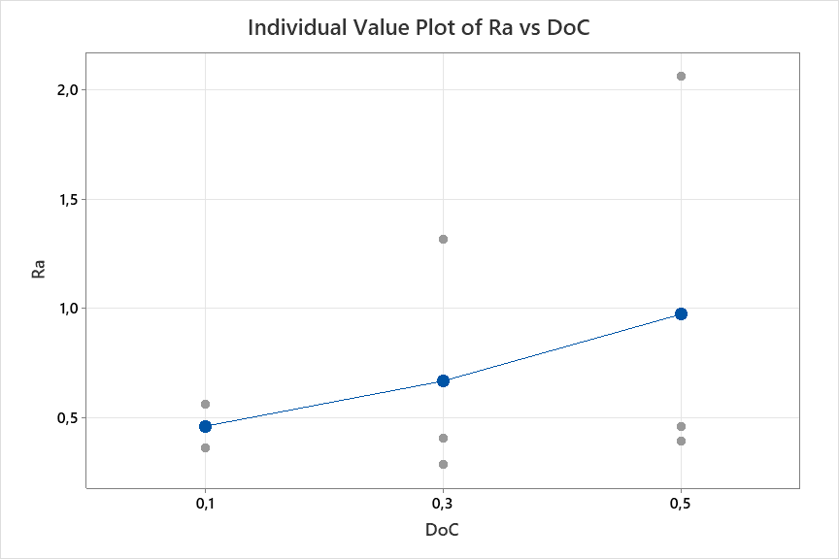

Figure 7: Correlation Ra and DoC

However, in correlation between depth of cut with surface roughness can show that deeper to cut the workpiece the surface roughness value more increase. Also same like feed rate, if feed rate increasing the value of surface roughness also will be increase. This parameter also synchronized with the result from another research [23,24].
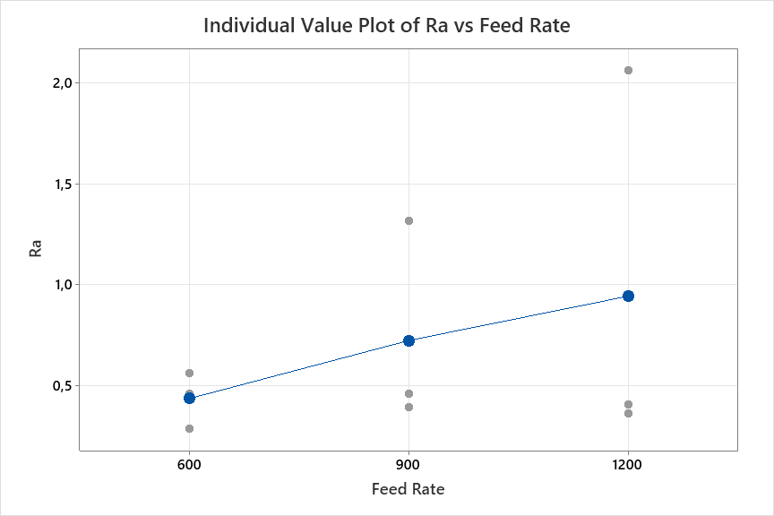
Figure 8: Correlation Ra and Feed Rate

From Figure 8 explain that Surface Roughness (Ra) and Feed Rate have correlation, that can show that if Feed Rate increasing the Surface Roughness value also increase. Surface roughness closely decreased with spindle speed and increased with feed rate. No separate confirmation experiment was performed to validate the optimal cutting conditions predicted by the Taguchi method. This remains a limitation of the present study. Future research should include validation runs to verify the reliability of the predicted optimal settings.

4.0 CONCLUSIONS

The experiment shows that all parameter has correlation to the test result and analysis using Taguchi Method and Anova to make more deeper with that parameter. From the experiment and analysis this research can conclude that:
- The surface roughness value is decreasing if the spindle speed is increasing. Spindle speed maximum on this experiment is 7000rpm, the feed rate and depth of cut value if decrease the value of surface roughness also decrease.
- The optimum condition from Taguchi method shows that spindle speed is 7000rpm, depth of cut is 0,1mm, feed rate is 600mm/min.
- From the Anova analysis, through that spindle speed has 72,14% contribution, feed rate has 11,26%, depth of cut has 9,82% and model has 6,78%. That mean the surface roughness on this experiment most influence is spindle speed compare to another three parameters.

ACKNOWLEDGMENTS

This work was supported by the “Geran Insentif Penyeliaan (GIP)” [600-RMC/GIP 5/3(123/2023), Influence of Triply Periodic Surface (TPMS) Lattice Design on Carbon Capture Performance of Direct Air Capture (DAC) System, Universiti Teknologi MARA and Dana Hibah Internasional, Universitas Sumatera Utara.

AUTHOR CONTRIBUTIONS

I. Siregar, J.B. Saedon and M.S. Adenan confirm the equal contribution in each part of this work. All authors reviewed and approved the final version of this work.

CONFLICTS OF INTEREST

The manuscript has not been published elsewhere and is not under consideration by other journals. All authors have approved the review, agree with its submission and declare no conflict of interest in the manuscript.

REFERENCES

[1] K.S. Al-Rubiaei, S. Melotti, A. Rabelo, J.M. Paiva, M.A. Elbestawi and S.C. Veldhuis, “Machinability of SLM-produced Ti6Al4V titanium alloy parts”, Journal of Manufacturing Processes, vol. 57, pp. 768–786, 2020.
[2] P.K. Gokuldoss, S. Kolla and J. Eckert, “Additive manufacturing processes: Selective laser melting, electron beam melting and binder jetting-selection guidelines”, Materials, vol. 10, no. 6, p. 672, 2017.
[3] A. Metel, M. Stebulyanin, S. Fedorov and A. Okunkova, “Power Density Distribution for Laser Additive Manufacturing (SLM): Potential, Fundamentals and Advanced Applications”, Technologies, vol. 7, no. 1, p. 5, 2018.
[4] O. Oyelola, P. Crawforth, R. M’Saoubi and A.T. Clare, “Machining of Additively Manufactured Parts: Implications for Surface Integrity,” in 3rd CIRP Conference on Surface Integrity, Charlotte, North Carolina, 2016, pp. 119–122.
[5] M.A. Sadiq, N.M. Hoang, N. Valencia, S. Obeidat and W.N.P. Hung, “Experimental study of micromilling selective laser melted Inconel 718 superalloy,” in 46th SME North American Manufacturing Research Conference, Texas, 2018, pp. 983–992.
[6] A.K. Singla et al., “Selective laser melting of Ti6Al4V alloy: Process parameters, defects and post-treatments”, Journal of Manufacturing Processes, vol. 64, pp. 161–187, 2021.
[7] V. Venkatesh, N. Swain, G. Srinivas, P. Kumar and H.C. Barshilia, “Review on the machining characteristics and research prospects of conventional microscale machining operations”, Materials and Manufacturing Processes, vol. 32, no. 3, pp. 235–262, 2017.
[8] S.A. Niknam, R. Khettabi and V. Songmene, “Machinability and Machining of Titanium Alloys: A Review”, Materials Forming, Machining and Tribology, pp. 1–30, 2014.
[9] Lizzul, L.; M. Sorgato; R. Bertolini; A. Ghiotti and S. Bruschi, “Surface finish of additively manufactured Ti6Al4V workpieces after ball end milling,” in 18th CIRP Conference on Modeling of Machining Operations (CMMO), Ljubljana, Slovenia, 2021, pp. 228–233.
[10] R. Davis and A. Singh, “Tailoring Surface Integrity of Biomedical Mg Alloy AZ31B Using Distinct End Mill Treatment Conditions and Machining Environments”, Journal of Materials Engineering and Performance, vol. 29, no. 11, pp. 7617–7635, 2020.
[11] J. Sun and Y.B. Guo, “A comprehensive experimental study on surface integrity by end milling Ti-6Al-4V”, Journal of Materials Processing Technology, vol. 209, no. 8, pp. 4036–4042, 2009.
[12] M.O. Qadri and H. Namazi, “Fractal-Based Analysis of the Relation between Surface Finish and Machine Vibration in Milling Operation”, Fluctuation and Noise Letters, vol. 19, no. 01, p. 2050006, 2019.
[13] M.P. Jahan, J. Ma, C. Hanson and G.K. Arbuckle, “Tool wear and resulting surface finish during micro slot milling of polycarbonates using uncoated and coated carbide tools”, Proceedings of the Institution of Mechanical Engineers Part B Journal of Engineering Manufacture, vol. 234, no. 1–2, pp. 52–65, 2020.
[14] R. Mead, S.G. Gilmour and A. Mead, Statistical principles for the design of experiments: applications to real experiments (Vol. 36). Cambridge: Cambridge University Press, 2012.
[15] K. Aslantas, E. Ekici and A. Çiçek. “Optimization of process parameters for micro milling of Ti-6Al-4V alloy using Taguchi-based gray relational analysis”, Measurement, vol. 128, pp. 419–427, Nov. 2018.
[16] S. Moshat, S. Datta, A. Bandyopadhyay and P.K. Pal, “Optimization of CNC end milling process parameters using PCA-based Taguchi method”, International Journal of Engineering Science and Technology, vol. 2, no. 1, 2010.
[17] V.S. de Viteri and E. Fuentes, E. (2013). “Titanium and Titanium Alloys as Biomaterials,” in Tribology-Fundamentals and Advancements. Croatia: InTech, 2013.
[18] M. Kulkarni, A. Mazare, E. Gongadze, Š. Perutkova, V. Kralj-Iglič, I. Milošev, P. Schmuki, A. Iglič, and M. Mozetič, “Titanium nanostructures for biomedical applications,” Nanotechnology, vol. 26, no. 6, p. 062002, 2015.

[19] Y.L. Hao, S.J. Li and R. Yang, “Biomedical titanium alloys and their additive manufacturing,” Rare Metals, vol. 35, no. 9, pp. 661–671, 2016.
[20] J.Z. Zhang, J.C. Chen and E.D. Kirby, “Surface roughness optimization in an end-milling operation using the Taguchi design method”, Journal of Materials Processing Technology, vol. 184, no. 1–3, pp. 233–239, 2007.
[21] E. Fereiduni, A. Ghasemi and M. Elbestawi, “Selective laser melting of aluminum and titanium matrix composites: Recent progress and potential applications in the aerospace industry”, Aerospace, vol. 7, no. 6, p. 77, 2020.
[22] S. Ramesh, L. Karunamoorthy and K. Palanikumar, “Surface roughness analysis in machining of titanium alloy”, Materials and Manufacturing Processes, vol. 23, no. 2, pp. 174–181, 2008.
[23] J.U. Pillai, I. Sanghrajka, M. Shunmugavel, T. Muthuramalingam, M. Goldberg and G. Littlefair, “Optimisation of multiple response characteristics on end milling of aluminium alloy using Taguchi-Grey relational approach”, Measurement, vol. 124, pp. 291–298, 2018.
[24] Awang, M., Wan Mohd, W., Sarifuddin, N., Tengku Ismail, T., and Harun, N., “Hybrid composites of polypropylene/rice husk/titanium dioxide: The effects of compatibilizer on the mechanical properties and morphology,” Journal of Advanced Manufacturing Technology (JAMT), vol. 15, no. 2, pp. 35–46, 2021.
[25] Musa, M., Juoi, J., Rosli, Z., and Moriga, T., “Influence of silver incorporation on the microstructure and crystallinity of TiO₂ coatings,” Journal of Advanced Manufacturing Technology (JAMT), vol. 16, no. 1, pp. 19–31, 2022.

